**Obstacle Avoidance Robot**

**Contents**

1. Introduction
2. Functionality Overview
   * 2.1. Code Explanation
3. Electrical Schematic and Physical Images

## ****Introduction****

This project presents the development of a robotic system capable of navigating autonomously while avoiding obstacles. The robot is programmed in Python and utilizes an ultrasonic sensor to detect obstacles in its path. If an obstacle is detected within a certain range, the robot stops, moves backward, and then changes direction to continue its journey.

This system serves as a foundation for building more advanced semi-autonomous robots. It can be expanded with additional sensors and control mechanisms to improve its efficiency and adaptability.

## ****Functionality Overview****

The robot uses a Raspberry Pi as its control unit and employs a set of motors to move in different directions. The obstacle detection mechanism relies on an ultrasonic sensor, which continuously measures the distance to objects in front of the robot.

When no obstacle is detected, the robot moves forward. However, if an obstacle is within a certain threshold distance (20 cm), the robot stops, moves backward briefly, turns, and then resumes its motion.

## Code Explanation

### Importing Libraries and Setting Up GPIO Pins

The script begins by importing the necessary libraries:

- RPi.GPIO: Used to control the Raspberry Pi’s GPIO pins.

- time: Used for delays in the program.

The GPIO mode is set to BCM (Broadcom) numbering:

GPIO.setmode(GPIO.BCM)

### Defining Pin Assignments

The following GPIO pins control the motor driver and the ultrasonic sensor:

- IN1, IN2, IN3, IN4: Motor control pins.

- TRIG & ECHO: Used for the ultrasonic sensor.

### Motor Control Functions

Functions are defined to control the movement of the robot:

- stop(): Stops the robot by setting all motor pins to LOW.

- inainte(): Moves the robot forward by setting the appropriate motor pins.

- spate(): Moves the robot backward.

- dr(): Turns the robot to the right.

- stanga(): Turns the robot to the left.

### Distance Measurement Using the Ultrasonic Sensor

The ultrasonic sensor sends a sound pulse via the TRIG pin, and the time taken for the pulse to return to the ECHO pin is measured. The distance is calculated using the speed of sound.

def distanta():

GPIO.output(TRIG, False)

time.sleep(0.1)

GPIO.output(TRIG, True)

time.sleep(0.00001)

GPIO.output(TRIG, False)

The **TRIG pin** is activated for **10 microseconds** to send a sound pulse.

The function then **measures the time taken for the echo to return**:

pulse_start, pulse_end = 0, 0

timeout = time.time() + 1

while GPIO.input(ECHO) == 0:

pulse_start = time.time()

if pulse_start > timeout:

return -1

while GPIO.input(ECHO) == 1:

pulse_end = time.time()

if pulse_end > timeout:

return -1

The **ECHO pin goes HIGH** when the pulse returns.

The time difference between pulse_start and pulse_end is calculated.

The distance is then determined using the speed of sound (343 m/s):

pulse_durata = pulse_end - pulse_start

dist = pulse_durata * 17150

dist = round(dist, 2)

return dist

### Main Loop – Obstacle Avoidance Logic

The main program runs in an infinite loop:

- If no obstacle is detected within 20 cm, the robot moves forward.

- If an obstacle is detected, the robot stops, moves backward, turns left, and continues moving.

### Cleanup on Exit

If the user interrupts the program (Ctrl+C), the robot stops and the GPIO pins are reset using GPIO.cleanup().

**Electrical Schematic and Physical Images**

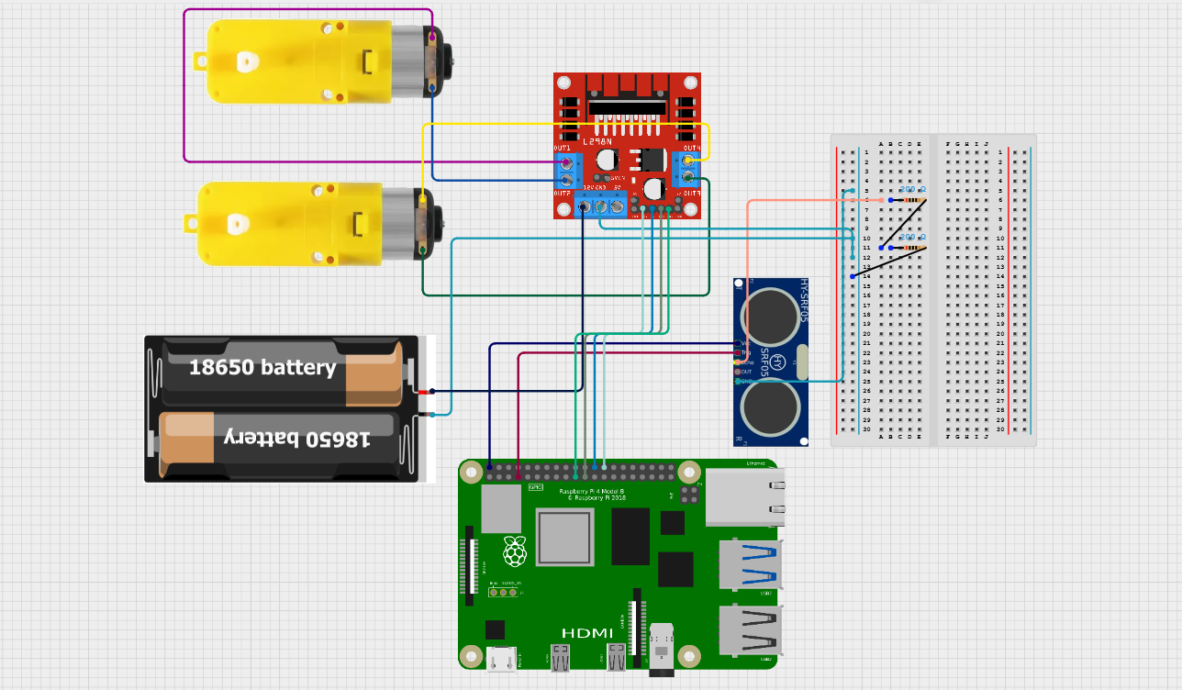

**Raspberry Pi (Controller)**

* The **Raspberry Pi** acts as the brain of the robot, processing sensor inputs and controlling the motors.
* It is connected to the **motor driver (L298N)** and **ultrasonic sensor** through its **GPIO pins**.

**L298N Motor Driver (Motor Control)**

* This module controls the two **DC motors**.
* It receives signals from the Raspberry Pi and adjusts the motor speed and direction accordingly.
* It is powered by the **18650 battery pack** to provide sufficient current for the motors.

**DC Motors (Robot Movement)**

* Two **yellow-geared DC motors** drive the robot’s wheels.
* They are connected to the **OUT1, OUT2, OUT3, and OUT4** terminals of the **L298N motor driver**.

**HC-SR04 Ultrasonic Sensor (Obstacle Detection)**

* Used to measure the distance to obstacles.
* It consists of two main components:
  + **TRIG (Trigger Pin)**: Sends ultrasonic pulses.
  + **ECHO (Echo Pin)**: Receives the reflected pulses and calculates the distance.
* The sensor is powered by the Raspberry Pi and connected via **GPIO pins**.

